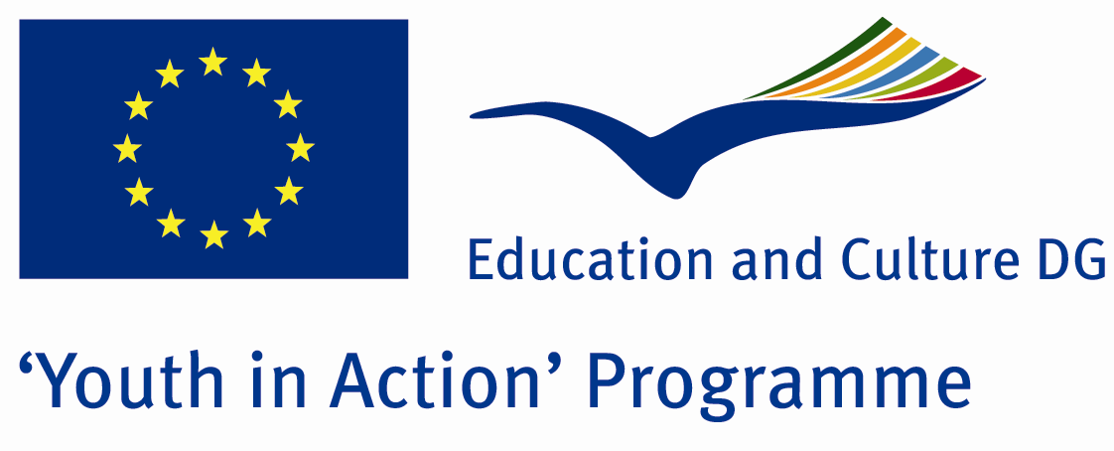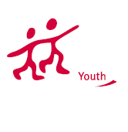

Unimpeded World



ACTION 1.1 – Youth Exchange

20-27th September, 2011

Sinop, TURKEY

ACTION 1.1 Youth Exchange
20-27th September, 2011
Sinop, TURKEY

Please contact directly to;
adventurerpeacepigeons@gmail.com

Project Summary; The theme of this project is disabled people. In the society, there is not enough understanding for the disabled people. Everybody says that they support the rights of disabled people, but in the daily life they ignore the disabled people. Don’t care for their problems, don’t try to understand how different problems they would have and do almost nothing for them. The people generally realise this problem exactly when they are disabled or the people they know. With this project, we will take interest of more young people and the society, discuss and understand more about the problems of disabled people and ignorance of society. So if you find this theme important, we need your partnership!

Project Title; Unimpeded World

Date and Venue ; 20-27th September , 2011 Sinop, Turkey .

Target Group ; Municipalities, City Councils and Non-Governmental organizations,
youth groups,culture and art groups,e.t.c

Participants ; 5 people from each country (over 18 -25 ). Totally 8 countries.

Conditions ; Accommodation, board and programme costs will be financed through European Commission Youth in Action Programme (Action 1.1). Travel costs will be reimbursed in 70% (APEX Tarrifs). Organizations from all 27 EU member countries plus Liechtenstein , Norway and Iceland are eligible to take part.

Working language: English

Organizer; Discovery And Adventure Group

How to apply: If you are interested, please send your Part III forms to
by e-mail please (in word file). Scan Part3 format is enough for application.(Fulfilled Part III which you can find in the attachment, of course signed and stamped) ..

…

Next step 2;
Original send via regular post to this address please:

Ertan DERİN
Fevzi Çakmak Mahallesi Tuncer Sokak No:6 PENDİK/İSTANBUL/TÜRKİYE
e-mail : adventurerpeacepigeons@gmail.com
Mobile : 0090 542 393 93 90

If you have any questions you may contact with: adventurerpeacepigeons@gmail.com
Deadline for application; until 15 may 2011.

For Further information:
Contact Person
Ertan DERİN
Fevzi Çakmak Mahallesi Tuncer Sokak No:6 PENDİK/İSTANBUL/TÜRKİYE
e-mail : adventurerpeacepigeons@gmail.com
Mobile : 0090 542 393 93 90

